C L Linfoot BlueConnect Employee GUIDE
Training guide for BCBSND’s online benefit enrollment solution

Table of Contents
WHAT IS BLUECONNECT 3
LOGGING INTO BLUECONNECT 3
EMPLOYEE HOMEPAGE 4
MY BENEFITS 5
Current Benefits 5
Life Events 6
MY PROFILE 6
Personal Information 6
Family Information 7
Beneficiaries 9
Life Event 9
LIBRARY 9
ENROLLMENT PROCESS 10

WHAT IS BLUECONNECT
BlueConnect is an online enrollment platform that you will use to enroll in your benefits. If you have questions or need assistance contact HR.

LOGGING INTO BLUECONNECT
To access BlueConnect go to linfoot.bswift.com .
To login follow the below steps:
- From the BlueConnect homepage enter your username and password
- Your username is the first initial of your first name followed by your full last name. (i.e. Judy Tester is JTester).
- Your initial password is the last 4of your social security number, upon login in for the first time you will be required to change it to a password of your choice.
- Enter a new password of your choice and click Save.
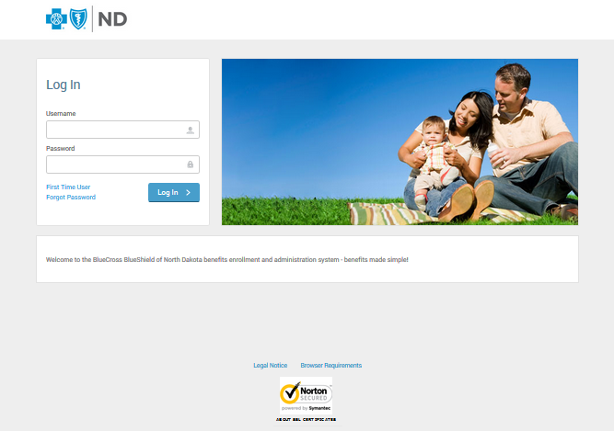
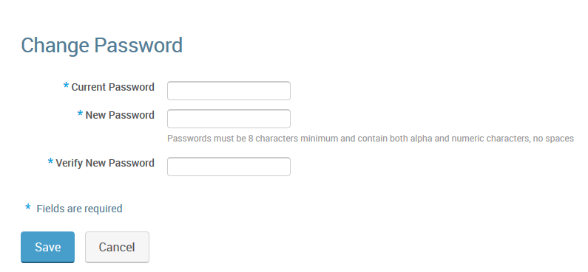

EMPLOYEE HOMEPAGE
After you have successfully changed your password, you will then see the homepage. The homepage is the page you will see every time you login. The homepage allows you to navigate to different sections of the site.
You are able to view your current benefits, process life events (i.e. marriage, birth etc.), your profile and a library containing import information and documentation. You can click the tab at the top of the page to view the information or use the links in the middle of the page.
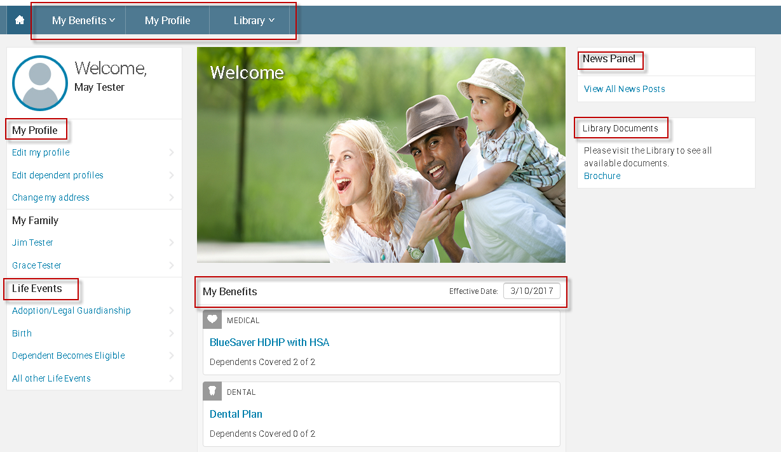

MY BENEFITS
My benefits will allow you to view your current benefit selections and process life events (i.e. marriage, birth etc.).

Current Benefits
Current Benefits will show you the plans that you’re currently enrolled in, who is covered under that plan, the cost of the plan and applicable plan details (i.e plan brochure). You do have the ability to view your benefits as of another date if need be.
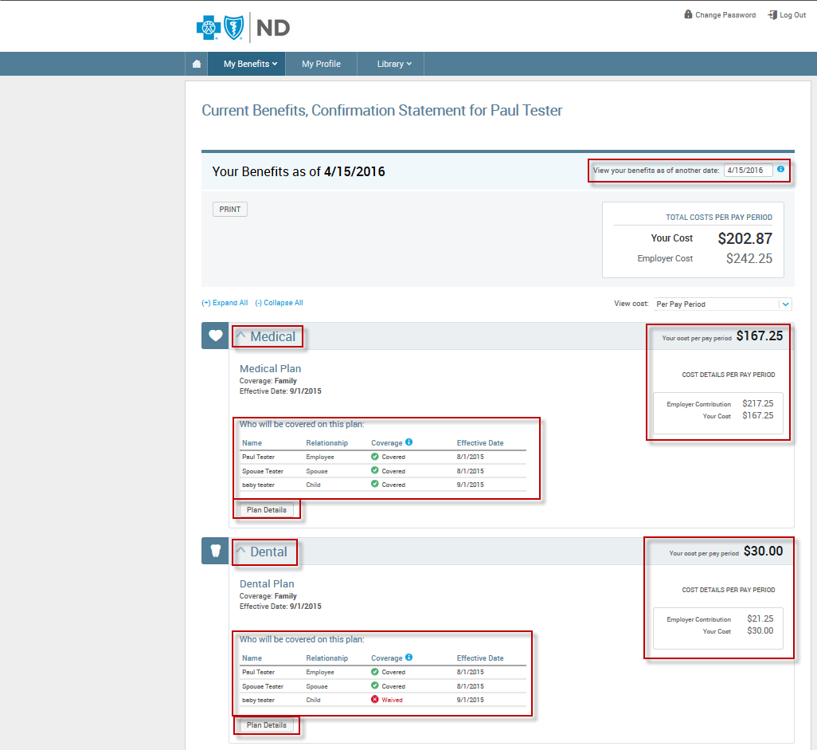

Life Events
Life Events allow you to process a life event that will open up a special enrollment that will allow you to make changes to your benefits. The changes that can be made will depend on the type of life event that has occurred.
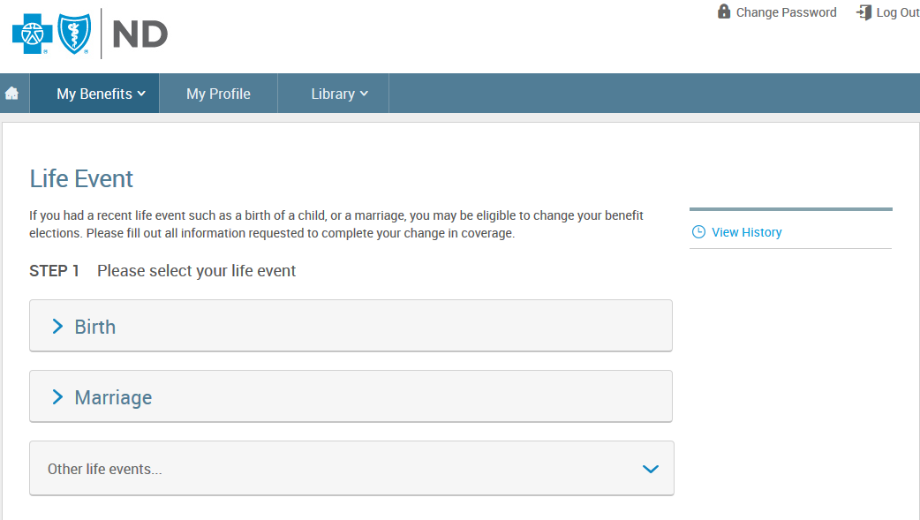
If you need to complete a life event choose the life event and complete the necessary information that is required to process the life event. Once you have completed the required information to process a life event you will want to go through the enrollment process to make the necessary benefit changes. Please click here if you need information on how to complete the enrollment process.

MY PROFILE
My profile allows you to see the current demographic information that is on file for you and your family, view and/or change beneficiary information, and process a life event.

Personal Information
This page allows you to see what demographic information is on file for you. If you need to make changes to your demographic information, click the Edit button to make the applicable changes. Some of the fields may not allow you to make changes, please contact HR in this situation.

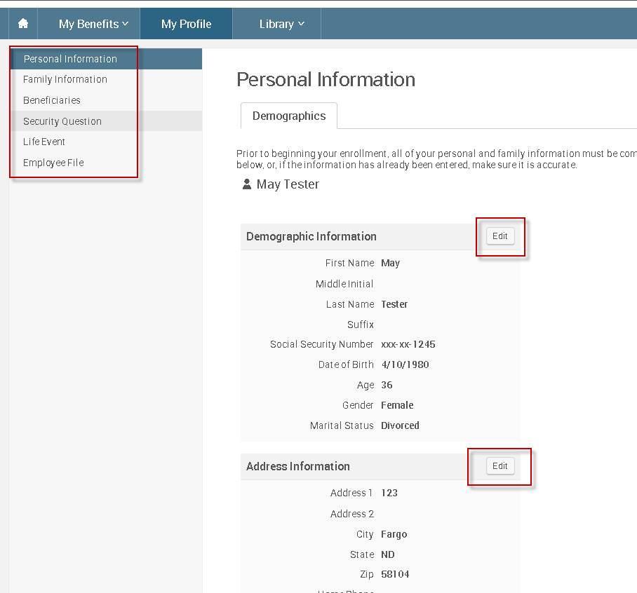

Family Information
This page allows you to see which family members have been added to your profile and allows you to add a new dependent.
To view and/or make changes to a dependent click on the Edit button. Some of the fields may not allow you to make changes, if there are changes that need to be made but you’re unable to do so you will need to contact HR.
To add a new dependent, click on the Add Dependent and complete the required fields. Then click Save to continue.
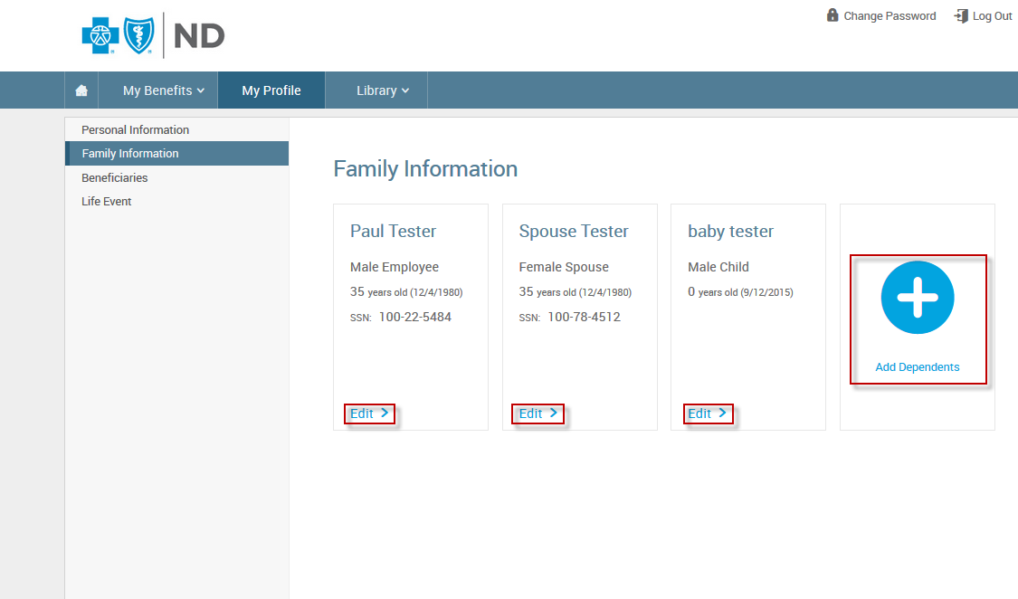
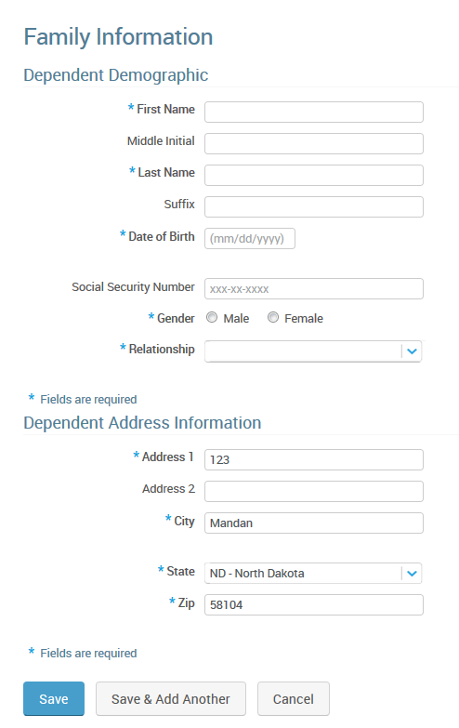

Beneficiaries
Allows you to see and change your designated beneficiaries for the applicable plans on BlueConnect.
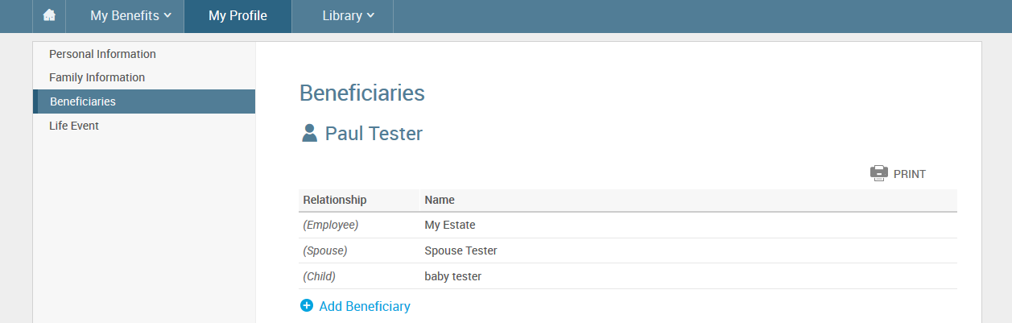

Life Event
Click here for more information on life events.

LIBRARY
The library allows you to view important documents and forms. Such as plan brochures, summary plan descriptions, etc. To view a document in the library, click on the title of the document.
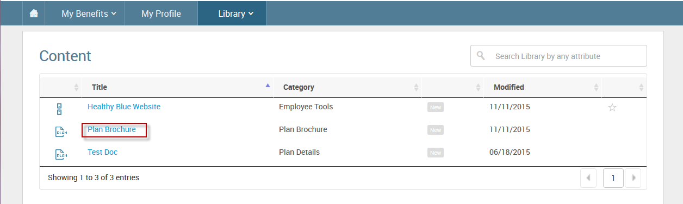

ENROLLMENT PROCESS
The enrollment process allows you to enroll in benefits as a new hire, special enrollment period or open enrollment. BlueConnect will walk you through the enrollment process.
To start follow the below steps:
- From the homepage click on the Change My Elections button
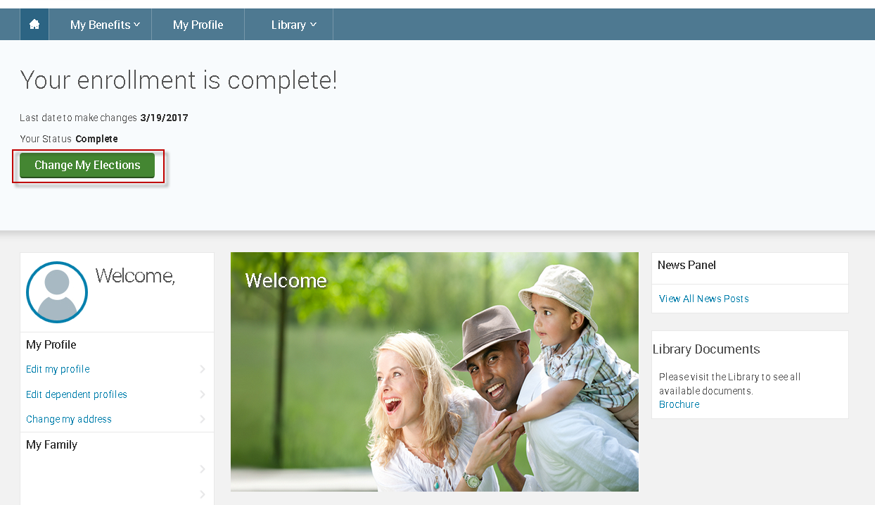
- Verify the information listed for you is correct and check “I agree” and click Continue. Make the necessary changes or contact HR to update any fields that cannot be edited in BlueConnect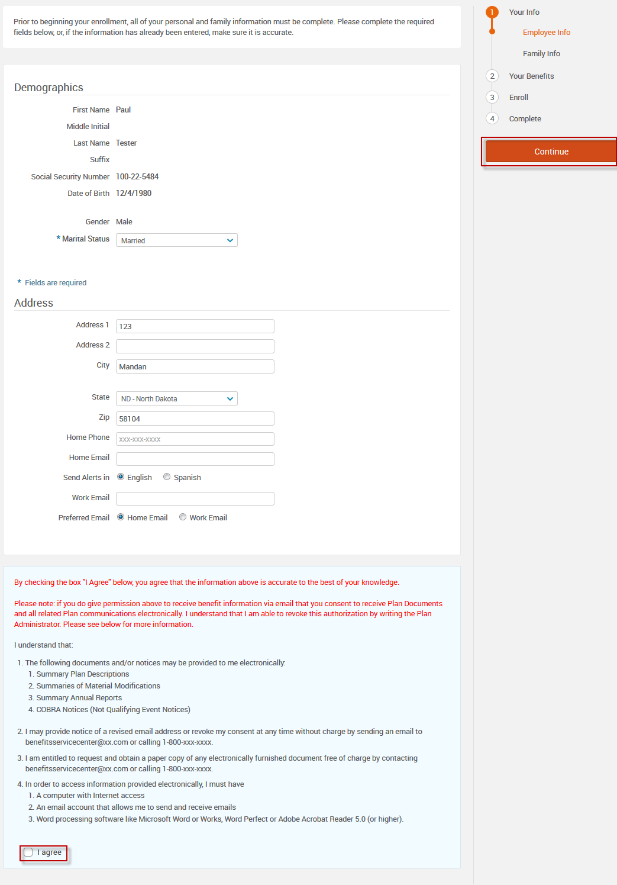

- Verify the information listed for your family is correct and check “I agree” and click Continue. If changes are needed make the necessary changes. Contact HR to update any fields that are not editable. If you need to add a dependent click “Add Dependent” and enter the required information.
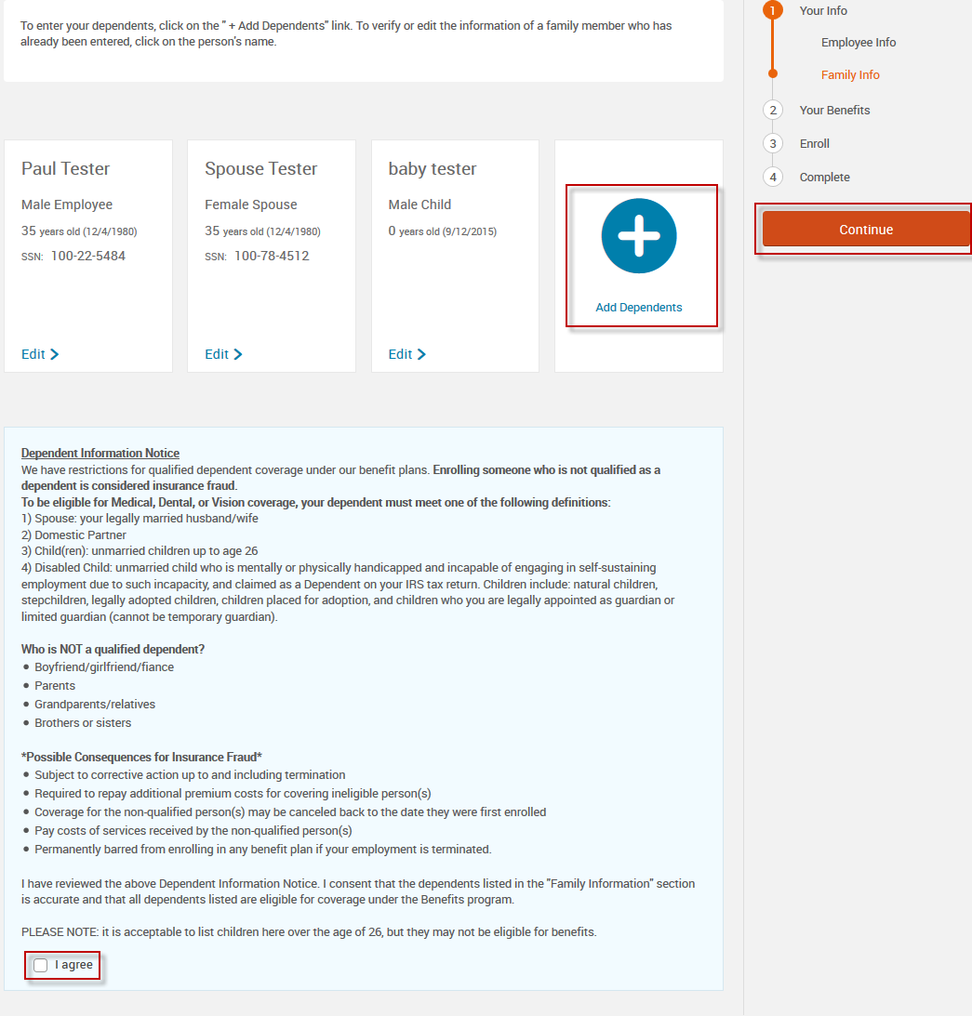

- The system will now step through the benefits that you are eligible to enroll in. You can select “I don’t want this benefit (waive)” or you can click on “View Plan Options” to learn more about the benefit. If you click “I don’t want this benefit (waive)” move to the next plan listed and make your election choice. If you click on “View Plan Options” you will determine who will be covered under the benefit. Once you have determined who will be covered you then can view the Plan Details for the plan and either select the benefit or waive, after you have made a selection you will be taken back to the Enroll page where you can continue to make your elections.
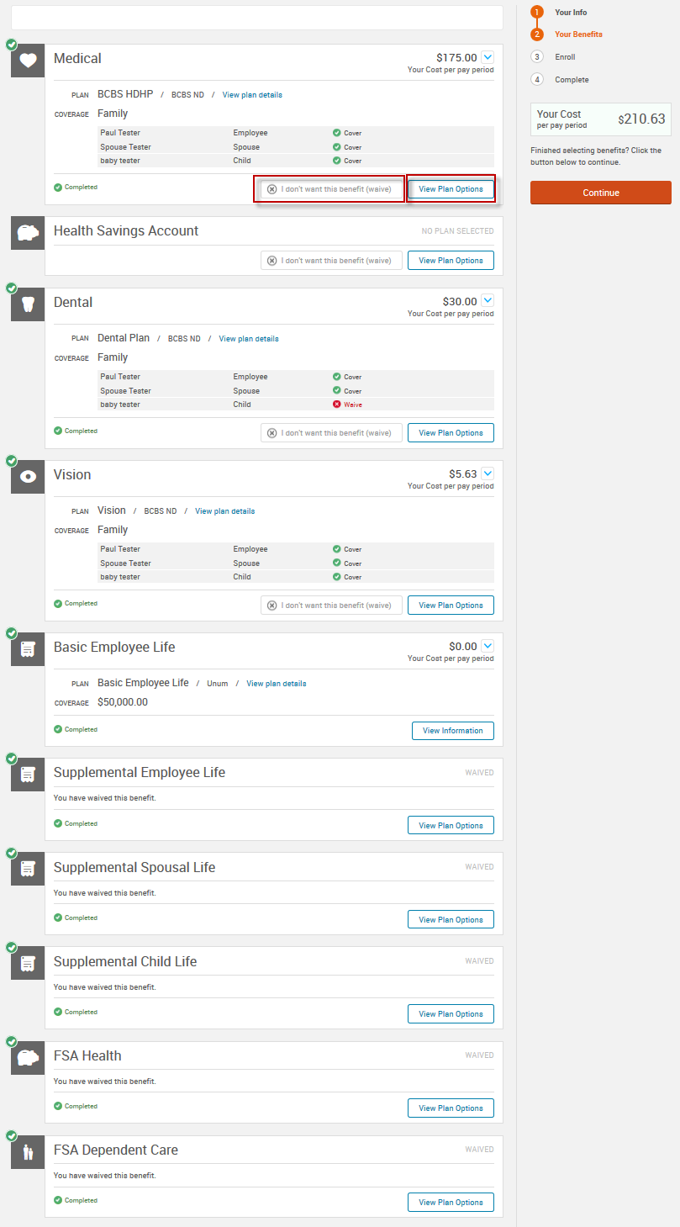
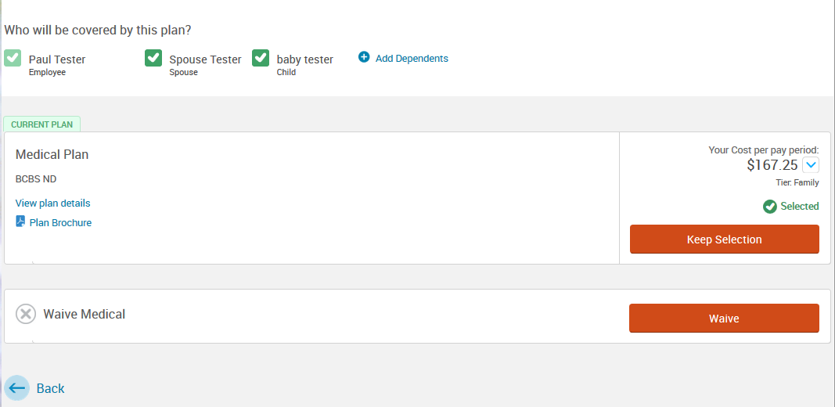
- Once you have made all of your elections you will need to review your benefit selections by clicking “Continue”.
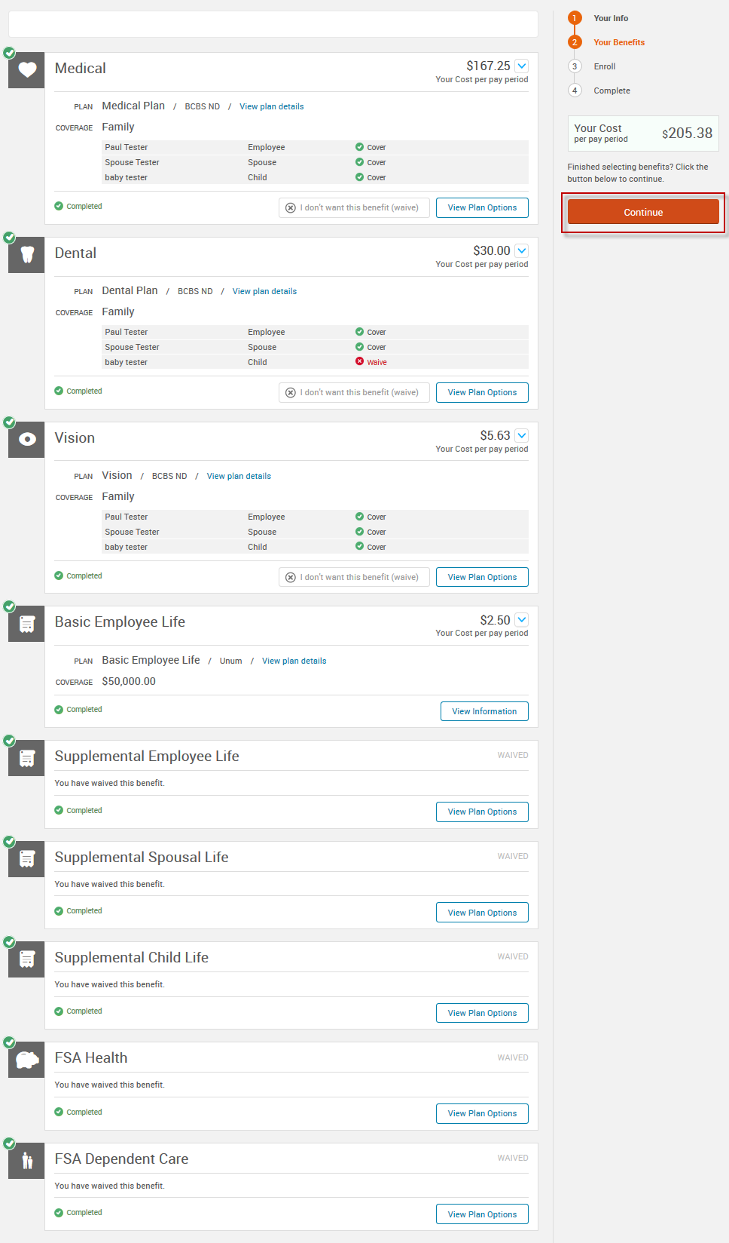

- You will now need to designate beneficiaries for any plans that require a beneficiary designation. After you have designated a beneficiary click “Continue”.
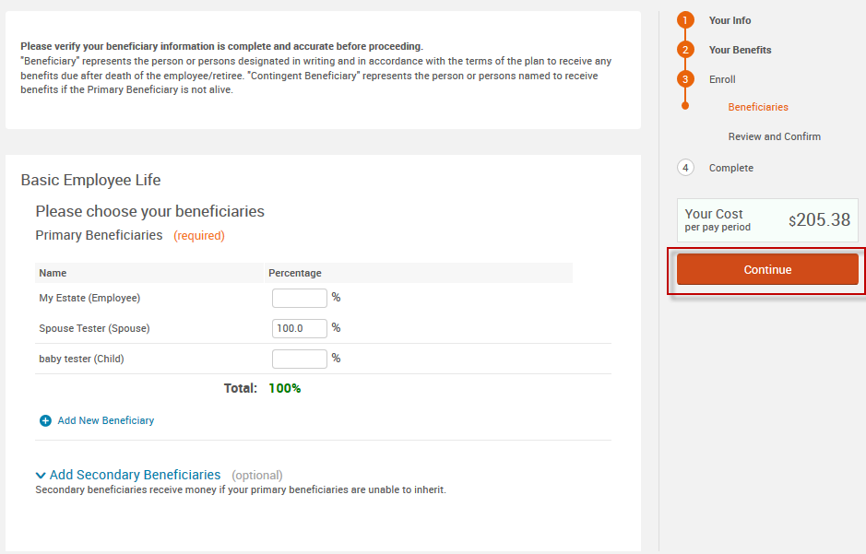

- You will now review your benefit elections to make sure that everything is correct. If you need to make any changes click on “Edit Selection” under the benefit plan in which a change is needed for to make the necessary change. If no changes are needed read and click “I agree” to the acknowledge statement at the bottom of the page and click “Complete Enrollment”.
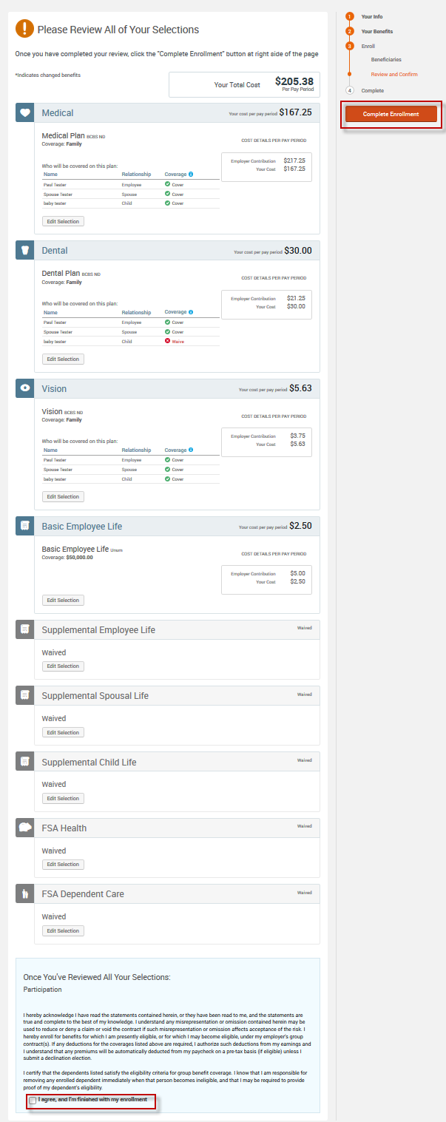
- Your enrollment is now completed; you can view a confirmation statement or print a copy for your records.
